**DAILY ONLINE ACTIVITIES SUMMARY**

|  |  |  |  |  |  |  |  |  |  |
| --- | --- | --- | --- | --- | --- | --- | --- | --- | --- |
| **Date:** |  | **02-06-2020** | | |  |  | **Name:** | **Suhas Prasad Shetty** | |
|  |  |  |  |  |  |  |  |  |  |
| **Sem & Sec** |  | **8th sem B sec** | | |  |  | **USN:** | **4AL16CS080** | |
|  |  |  |  |  |  |  |  |  |  |
|  |  |  |  |  | **Online Test** | | **Summary** |  |  |
|  | |  |  |  |  |  |  |  |  |
| **Subject** | |  | **-** |  |  |  |  |  |  |
|  | |  |  |  |  |  | |  |  |
| **Max. Marks** | |  | **-** |  |  | **Score** | | **-** |  |
|  |  |  |  |  | |  | |  |  |
|  |  |  |  | **Certification Course Summary** | | | | | |
|  | |  | |  | | | |  |  |
| **Course** |  | **CloudEndure Migration Training-Business** | | | | | |  |  |
|  |  | | |  |  |  | |  |  |
| **Certificate Provider** | | | | **AWS** |  | **Duration** | |  | **40 mins** |
|  |  |  |  |  |  |  | |  |  |
|  |  |  |  |  | **Coding Challenges** | | |  |  |

**Problem Statement-** : c++ prog to find sum of digits until the number is a single digits

**Status: completed**

|  |  |
| --- | --- |
| **Uploaded the report in Github** | **yes** |
|  |  |
| **If yes Repository name** | **Suhas** |
|  |  |
| **Uploaded the report in slack** | **yes** |
|  |  |

**Certification Course Details:**

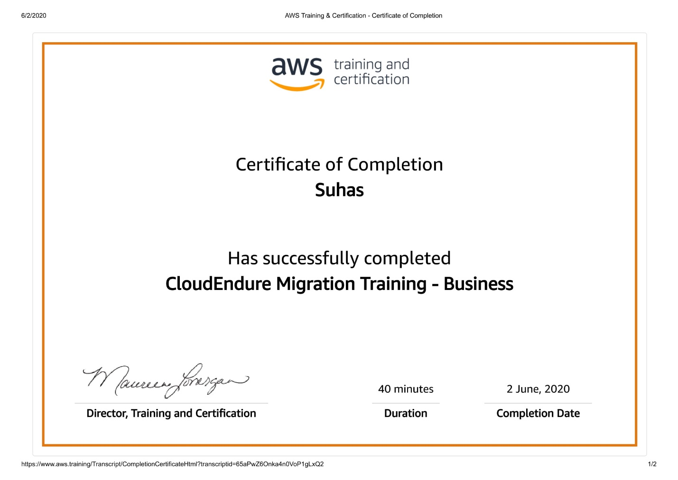

**Coding Challenge details:**

**c++ prog to find sum of digits until the number is a single digits**

#include

using namespacestd;

intmain()

{

intnumber=147;

//Any number.intres;

if(number) res=number%9==0?9:

number%9;

else res=0;

//print the result cout<<res;

Return 0;

}